**Introduction to Git and GitHub**

**Task 1 – Create a new repo remotely, clone it into the local machine, add a file and push the new file to the remote repo.**

Step 1: Create a Repo in GitHub. This Repo will be named ‘Masters_Degree’ and will be public.

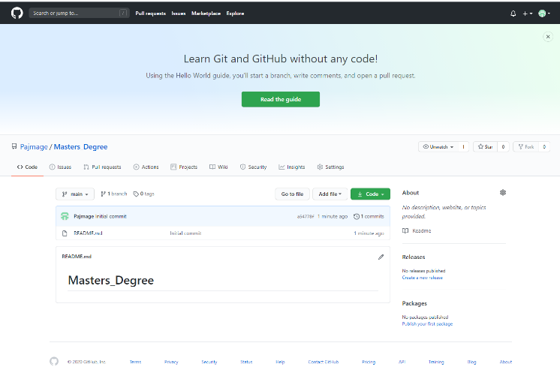  
Fig 1. New Repo created inside GitHub

Step 2: Configure Git on the local machine. This is done via the Git Config commands.

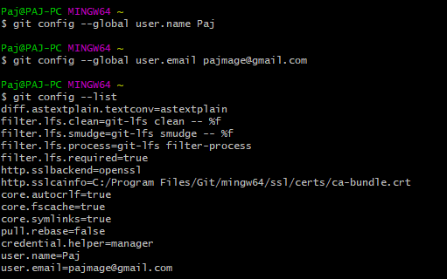

Step 3: Clone the Repo down into the local machine in a specific folder:

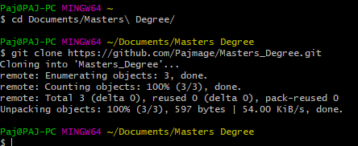

Step 4: Create a file locally and push it up to the GitHub Repo:

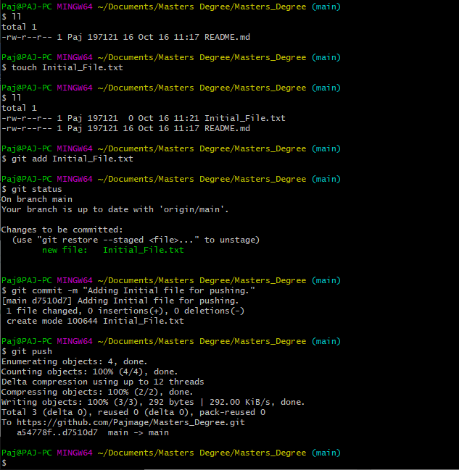

Step 5: Check the push was successful on GitHub:

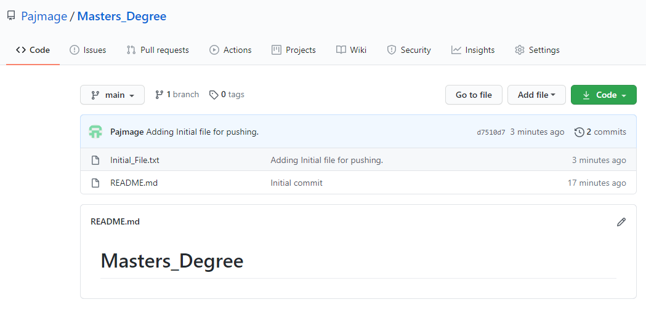

**Task 2 – Create a new repo locally, clone it into the local machine, add a file and push the new file to the remote repo.**

Step 1: Create the new folder and initialise it as a Git Repo with ‘git init’ command:

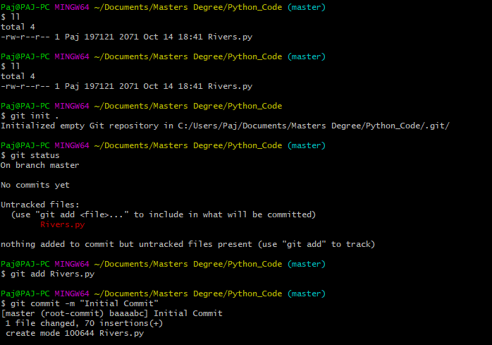

Step 2: Create Repository on GitHub with same name:

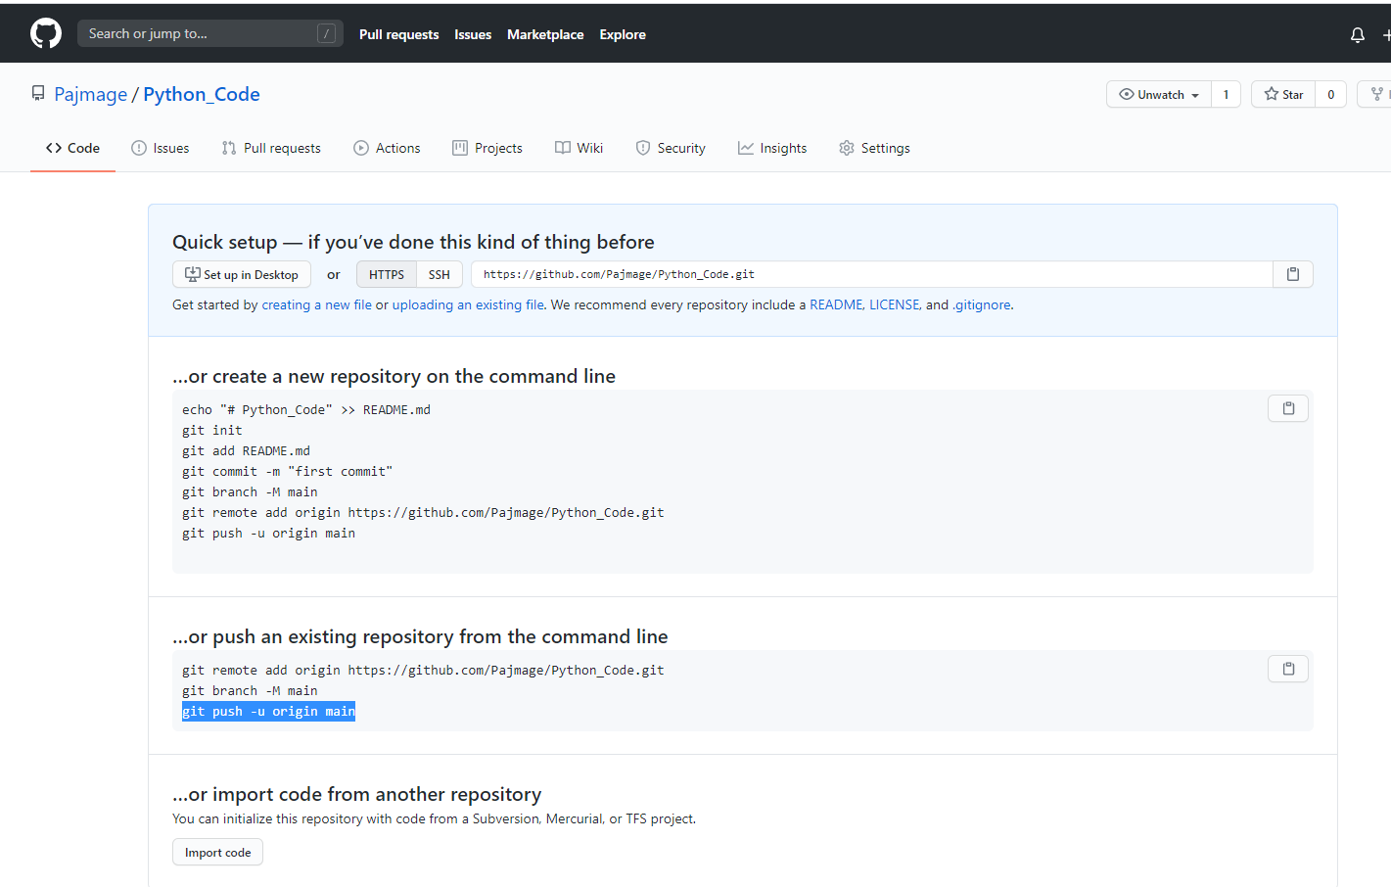

Step 3: Add the remote origin, set the branch to main and push the initial commit:

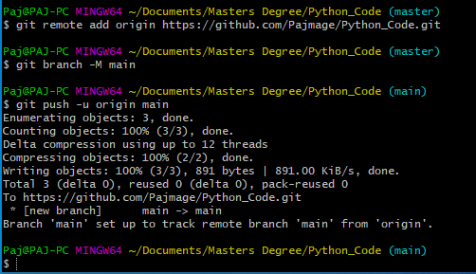

Step 4: Confirm the remote repository has been updated:

